Name: Haseem Farooq

Student ID: 467020

Lab manual 5

Lab Task

1. Convert the following while loop to a do-while loop:

int x = 1;

while (x > 0)

{

cout << "enter a number: ";

cin >> x;

}

INPUT:

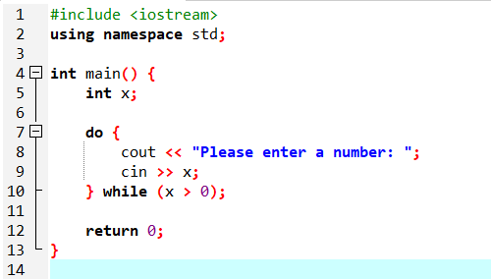

OUTPUT:  
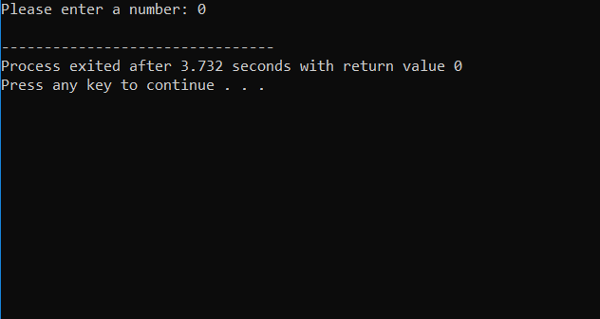

1. Use a do while loop to make a simple calculator for two numbers. Insert buttons for it to ask again and for termination.

INPUT: 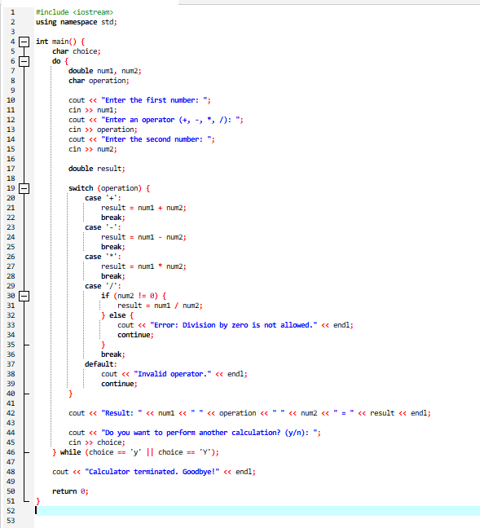OUTPUT:  
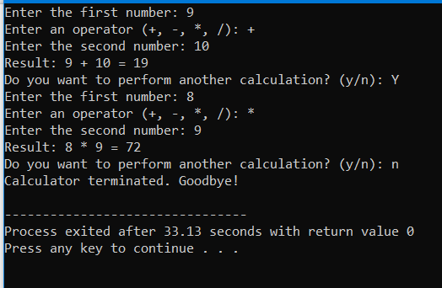

1. Write programs with while or do while loops that compute:

a. The sum of all even numbers between 2 and 100 (inclusive).

INPUT:

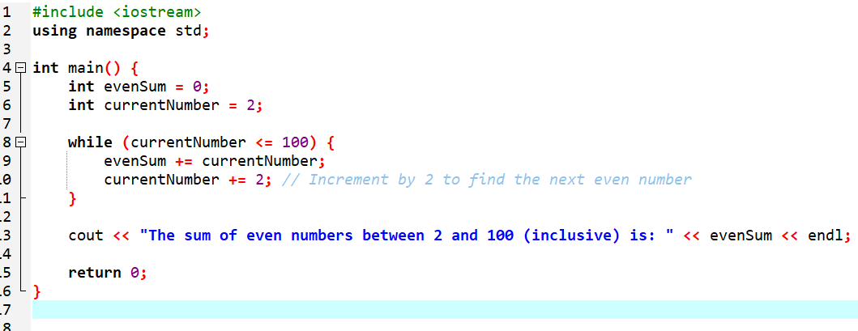

OUTPUT:  
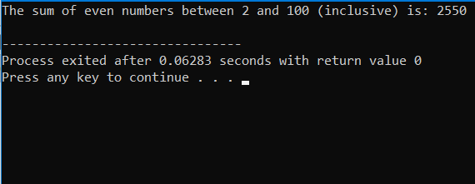

b. The sum of all squares between 1 and 100 (inclusive).

INPUT:  
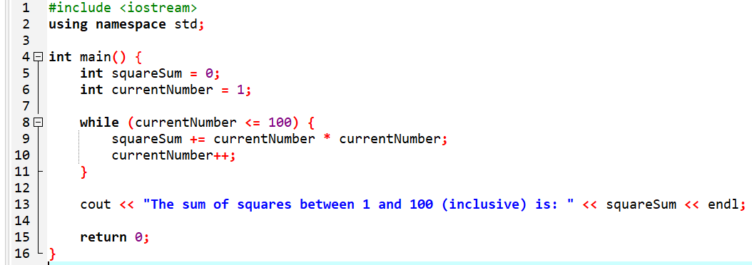

OUTPUT:

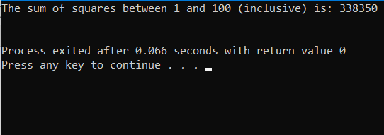

1. Write programs with while or do while loops that compute:
2. All powers of 2 from 2^0 up to 2^20

INPUT:  
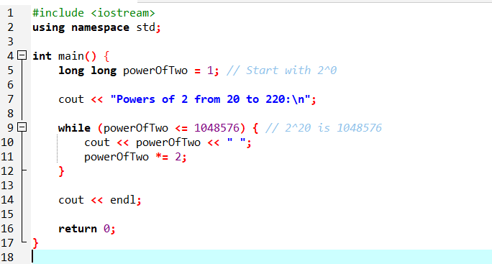

OUTPUT:

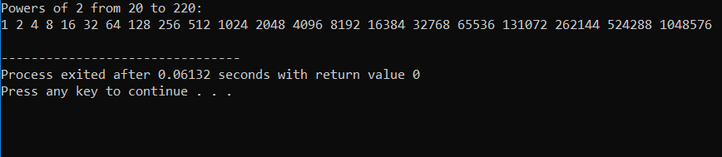

1. The sum of all odd numbers between a and b (inclusive), where a and b are inputs.

INPUT:  
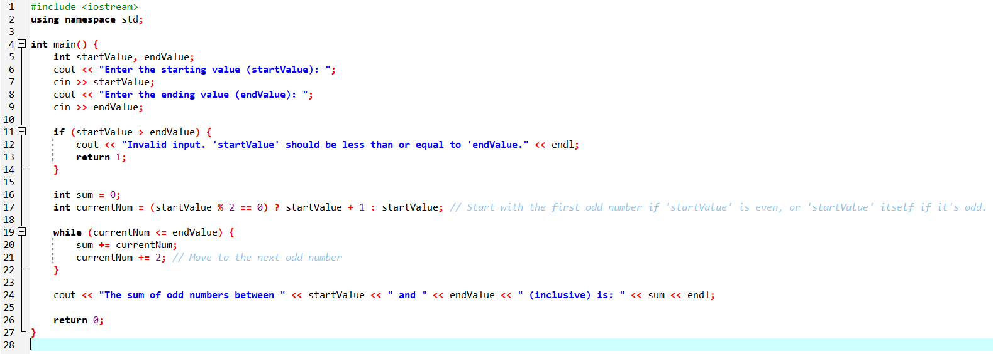

OUTPUT:  
